GAIT ANALYSIS USING MACHINE LEARNING CLASSIFIERS
student: JUMMA MOHAMMAD TELI (231034661)
Supervisor: TAYYAB AHMAD ANSARI
MSc INTERNET OF THINGS AND FUTURE NETWORKS

Abstract: This study on applying machine learning classifiers to the analysis of gait patterns with marker-based motion capture data. In this research, walking speeds have been classified as an important indicator of health conditions in many respects for different categories of individuals. In this work, a full dataset was pre-processed with kinematic and kinetic data from gait trials and classified against multiple machine learning models such as Random Forest, k-Nearest Neighbours, Support Vector Machines, Neural Networks, Gradient Boosting, Decision Trees, Logistic Regression, and Naive Bayes classifiers. Of these models, the Random Forest classifier was most efficient in obtaining an accuracy of 0.99, followed by the k-NN classifier with an accuracy of 0.98. The research has hence focused on this part of feature engineering in almost deriving these important features like distance and velocity from raw marker data. Second, the research substantiates a way of using a chunking technique for SVM training that makes large-scale dataset processing efficient. This ensured that the SVM would process large datasets quickly while maintaining high accuracy. These findings indicate that ensemble methods and non-parametric models show a great deal of promise in the classification of gait speed, coming up with reliable tools for either clinical or rehabilitation practice. The results will help in pushing forward techniques of gait analysis, further enabling practical insights into the early diagnosis of abnormalities in gait and monitoring the progress of rehabilitation.

Keywords: Gait Analysis, Machine Learning, Walking Speed Classification, Motion Capture, Random Forest, k-Nearest Neighbours, Feature Engineering, Rehabilitation, Clinical Gait Analysis.

I. Introduction

Recent advances in motion capture and machine learning have greatly improved gait analysis, especially in the field of ankle rehabilitation [1, 2]. Traditionally, gait analysis relies on marker-based systems that capture and quantify movement mechanics. While these traditional systems are effective, they are usually labour-intensive and risky to errors due to the complex nature of handling the data manually [3]. Integration of machine learning into gait analysis mitigates these challenges by automating the process, hence improving the accuracy and efficiency of the analysis [4]. This will be important, especially in rehabilitation situations where the accurate assessment of ankle movements is paramount [1]. Machine learning offers real-time diagnosis and monitoring with the ability to detect at an early-stage anomalies in walking patterns [5]. It can hence be crucial in the diagnosis and treatment of disorders such as Parkinson's and cerebral palsy, the outcome of which greatly relies on how early in life they are detected and treated [5].

This project deals with the analysis of gait phases by means of a dataset collected through an infrared cinematography system and an instrumented split-belt treadmill, which includes data for 3D marker positions and ground reaction forces [2]. The objective is to find out the percentage duration of different gait sub-phases—stance, loading response, mid-stance, terminal stance, pre-swing, and swing—with respect to walking speed. [6]. This work is to come up with a machine learning model that classifies and analyzes these gait phases in an attempt to enhance the efficacy of ankle rehabilitation [4].

II. Background and Motivation

Background: The study of human walking patterns is called gait analysis, which forms a key component in many clinical and research applications for the diagnosis of movement disorders, monitoring rehabilitation progress, and assessment of therapeutic interventions [6]. Traditionally, the analysis is done using a marker-based motion capture system that assumes the movement from markers attached to the body. Such systems produce large volumes of kinematic and kinetic data, which yield very detailed information on gait mechanics, including joint angles, forces, and velocities [17]. However, the high volumes and complexity pose a serious challenge in themselves—a mostly high-dimensional, noisy set of data riddled with missing values [3]. Apart from being time-consuming, manual handling of such data is error-prone and was complicating the accurate analysis of gait patterns.

Traditional gait analysis methods are usually very simplistic and hence only suitable for low-dimensional signals; this also brings out the need for better techniques [1]. Machine learning offers a breakthrough solution and a distinct move away from the outlined challenges. Machine learning provides a robust set of tools in automated feature extraction, dimensionality reduction, and pattern recognition, which facilitates easier and more accurate analysis of the complex data resulting from gait information [4, 14]

Motivation: In general, there is still room for improvement in terms of accuracy, efficiency, and applicability in the setting of a clinic/rehabilitation centre. Walking speed—an indicator of health and mobility for an individual—remains to be classified effectively due to the subtle variations and high dimensionality of the data. [5]. The exact assessment of these variations is very important in conditions like Parkinson's disease, cerebral palsy, and other movement disorders, as it guides the need for early diagnosis and treatment planning [1].

Such data is availed by the Gait Phase Database used in this study, capturing data from 21 healthy subjects walking at various speeds on a split-belt treadmill. It provides a unique opportunity to understand the biomechanics of gait and test machine learning algorithms for classifying different gait phases [17]. This paper details the development of models, using machine learning, that can classify walking speeds with a high degree of accuracy in the presence of noisy or incomplete data. In this respect, different classifier designs would be drawn upon to obtain an effective gait speed classification tool and, secondly, to show how this approach is pragmatically useful for clinical applications in real life. In this study, a systematic comparison was done between random forest, k-nearest neighbours, support vector machines, and neural networks within the remit of establishing which are the best approaches for gait speed classification and showing their practical utility in real-world clinical applications [7, 9]

Ultimately, the objective of this research is to work toward furthering gait analysis by providing clinicians and researchers with reliable, automated tools that can have an impact on better patient outcomes through more accurate and more efficient analyses of gait patterns. Such results could offer significant contributions to the creation of next-generation gait analysis systems integral to modern healthcare and rehabilitation practice.
Significance of the study: This study contributes to a rapidly growing literature on the use of machine learning in gait analysis and ankle rehabilitation [15, 16]. It provides valuable insights into the areas of biomechanics, motor control, sports science, and rehabilitation. This challenge of classifying the walking speeds using high-dimensional marker data is effectively addressed in the research, and the developed techniques apply to other areas of human movement studies, including upper limb or balance studies [9]. By comparing several classifiers, this work points out the strengths and weaknesses of every model, thus helping model selection and further development in human movement pattern analysis [10, 14]. It also fills gaps in the literature by applying state-of-the-art analysis techniques to a relatively under-explored gait database, thus opening the way toward the potential improvement of diagnostic and treatment strategies related to abnormal or pathological gait patterns. [1,2].

Table 1 :- Summary of Key Research Approaches and Findings in Gait Analysis
Research Focus | Approach | Key Findings | References
Gait Analysis using CNN | Deep learning techniques, specifically a CNN based on VGG-19 | Outperformed the ResNet50 model in distinguishing between normal and abnormal gait patterns | [11]
Human Gait Activity Recognition | Attention-based convolutional and recurrent neural networks | Achieved 98.9% accuracy, 96.8% precision, 97.8% sensitivity, 99.1% specificity, and a 97.3% F1-score: effective in detecting freezing gait in Parkinson's patients | [12]
Pathological vs. Physiological Gait Classification | Probabilistic Neural Networks (PNN) and Naive Bayes (NB) classifiers | PNN achieved 91.13% accuracy, NB reached 90.38% accuracy; the accuracy tied to data collection quality and precision | [10]
Classifying Neurodegenerative Diseases based on Gait | Support Vector Machines (SVM) | Maximum accuracy reported was 93.96% | [13]
Impact of Artificial Intelligence on Gait Analysis | Enhances gait phase identification with sensor data. | SVM and RF classifiers enable accurate gait phase identification, aiding ankle rehabilitation. | [5]
Classifying Parkinson's Disease (PD) vs. Other Diseases | Used gait characteristics from time-series data, applied feature extraction, and selected best features using a correlation matrix. | Achieved 83.33% accuracy, with a 75% detection rate for PD and a 16.67% false positive rate using an SVM model. | [26]
Neurodegenerative Disease Classification | Nonlinear gait signal analysis using wavelet transform, ICA, genetic algorithm, and AdaBoost classifier | Achieved 92.34% ± 2.1% accuracy in classifying diseases like Huntington's, ALS, and Parkinson's from control subjects | [27]

III. Methodology

In this paper, various machine learning algorithms have been comparatively evaluated with the dataset acquired from the GaitPhase database for gait phase classification. [Fig. 1: methodology]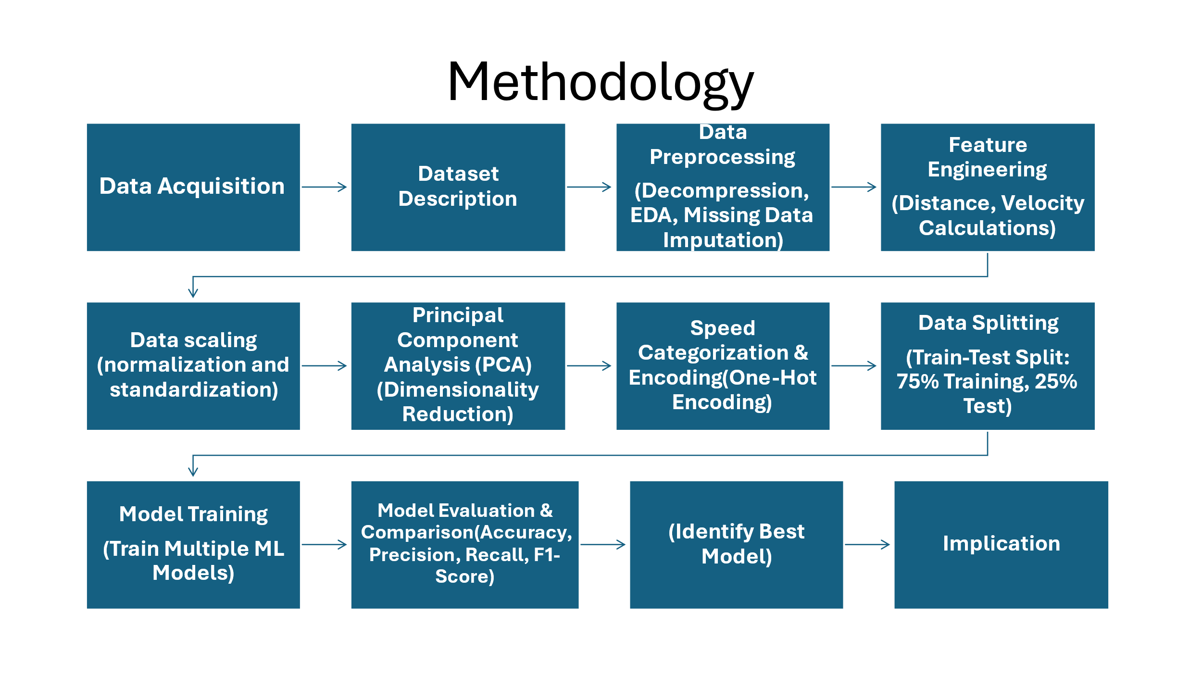
Fig, 01 – methodology

Data Acquisition: The database of GaitPhase includes data from 21 participants where there is 10 male and 11 female participants with average age of 23.8 years, 172.8 cm height, 66.6 kg weight. The dataset contains a total of 25,306 steps recorded on a split-belt motorized treadmill set to run at 12 different speeds, ranging from 0.6 to 1.7 m/s, for a duration of 1 min at each speed. Kinematic data were captured using the Qualisys motion capture system at 200 Hz, whereas kinetic data were captured from the Bertec split-belt treadmill at 1,000 Hz. This sophisticatedly synchronized data has an enormous worth for studying human gait and supports a wide variety of research applications, including gait asymmetry and the effectiveness of rehabilitation interventions [17].

Dataset Description: A CSV formatted dataset presents time-series data of the x, y, and z coordinates of markers on the lower limbs, especially on the feet and ankles. In fact, it demonstrates a huge spread of walking speeds for this dataset, making it very informative about different gait patterns, and at the same time, allowing an examination connected to the mechanics of gait both in the spatial and time domain [17].

Data Preprocessing: Due to the presence of noise, missing values, and other irregularities, raw data requires preprocessing. In the initial stage, the dataset was decompressed, read to pandas Data Frames, and exploratory analysis ensued. Descriptive statistics were computed, and that's true that due to the data visualization, one can get an idea of the unsual features of the data [4, 10, 14]. This imputed the missing data with the mean value for the column, thereby leaving the data unchanged [3, 8] [section VII -Fig 2, Fig 3, Fig 4 & Fig 5]
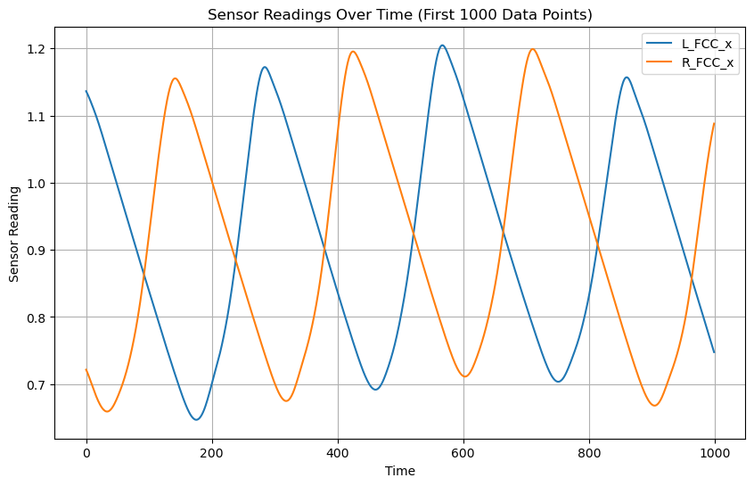Fig. 3 : Sensor Readings Over Time

Feature Engineering: Feature engineering is the process of creating meaningful features from raw positional data. To quantify essential features of gait mechanics, some of the features are derived from the raw marker data. Distances for pairs of markers were established to enable comparisons of the spatial relationship between various segments of the foot in the walking process. These distances are of importance to factors such as stride and step width, that data needs to be collected on. Other than the distances, velocities were also estimated using derivatives of position data with respect to time. The features of velocity help to describe specific attributes of the dynamics of the gait, in this case the magnitude of movement and the direction, which is needed for the identification of the phase. Besides, both standardization and normalization have been carried out to make the data ready to be put in use in training a model [9, 10, 14].[Section VII- APPENDICES Fig 6, Fig 7, Fig 8, Fig 9 & Fig 10]

Principal Component Analysis: This was done to decrease the dimensions while maintaining the most vital information of variance in the data. This step helped avoid overfitting in the model [18, 19]. [Fig. 11]
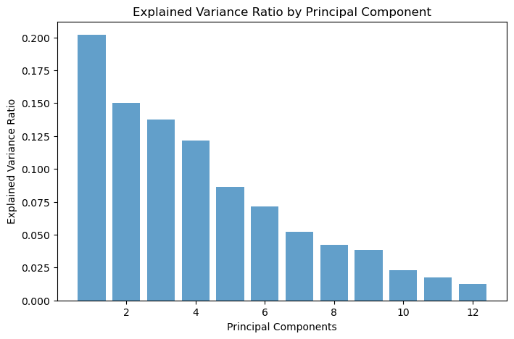Fig. 11 : explained variance ratio by principal component

Speed Categorization and Encoding: The continuous speed variable was categorized into categorical data; hence, the different gait speeds were categorized from very slow speed, slow speed, medium speed, fast speed, and very fast speed. The categorization was based on fixed speed intervals, after which they were encoded using one-hot encoding. These were further converted to binary format through one-hot encoding so that it would feed the machine learning models properly. In this way, proper predictions can be made on the gait speeds[14, 20].

Data Splitting: The datasets were split into a training set of 75% and a test set of 25% to ensure using a good deal of the data in training the model but testing the true efficacy of the model on another different set [25].

Machine Learning Models:
Random Forest Classifier: Training this model requires the number of the PCA-transformed features to be 100, with the number of trees equal to 100. Model performance will be evaluated in terms of classification reports identifying key predictors and misclassification patterns through confusion matrices and feature importance plots [7].
Logistic Regression: Both L1 (Lasso) and L2 (Ridge) versions have been trained and tested with the model using a classification report, confusion matrices, and cross-validation to compare the handling of different types of configured data [14].
Neural Network: A two-layer neural network with dropout trained using the Adam optimizer for 50 epochs. The performance was evaluated using classification accuracy, confusion matrices, plots of training/validation loss and accuracy. Performance was assessed using classification reports, confusion matrices and visualizations of the model to show that it was able to reduce bias [29].
k-Nearest Neighbors (k-NN): A k-NN classifier model was fitted with k=5 and evaluated through cross-validation, classification reports, and confusion matrices. Visuals were used to show the accuracy of prediction versus measurement. [14, 25].
Decision Tree: A model that was trained to split the data according to the values of features and which uses the classification reports and confusion matrices for the evaluation of the best splitting operation. Visualizations on how decisions are made [7, 14]
Naive Bayes Classifier: A Gaussian Naive Bayesian model was trained using cross-validation evaluation. The following were the classification reports and confusion matrices, achieving high effectiveness through a probabilistic approach [14, 20]
SVM Classifier: Trained and evaluated in chunks due to the large dataset size. Performance was summarized with overall accuracy, classification reports, and confusion matrices, highlighting its ability to handle high-dimensional data [28].

Model Evaluation and Comparison:
These models were evaluated for their possible accuracy, precision, recall, and F1 score. Optionally, confusion matrices were built to check the class distribution of the classification achieved through them and feature importance analysis in models like Random Forest and Gradient Boosting [7, 22]. Cross-validation was done to avoid overfitting the models and to gain model accuracy across gait speed categories [22].

Integration with the Rehabilitation System: The best-performing model was embedded in a rehabilitation system that provided real-time feedback during exercises. This system tracks patient movement with a marker-based motion-capture system, further categorizes gait speed, and reviews and adjusts rehabilitation programs accordingly [23].

IV. Result

Best Performer Model: The Random Forest Classifier performed to be the best with an accuracy of 0.99. The model returned an overall high precision, recall, and F1-scores across all classes with a very minimal case of misclassification as shown by its confusion matrix. Its immunity to noise and capability to process high-dimensional data added to the advantages that placed this model at the top. Thus, Random Forest is a very reliable option in the classification of gait speed. [Section VII, Fig 12 & 13 as appendices.]

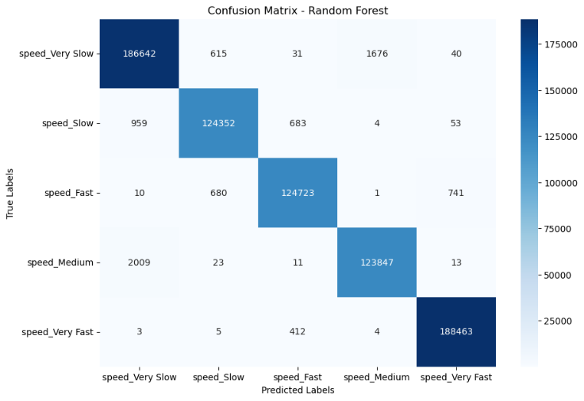Fig. 12: Random Forest Confusion Matrix for Speed Prediction

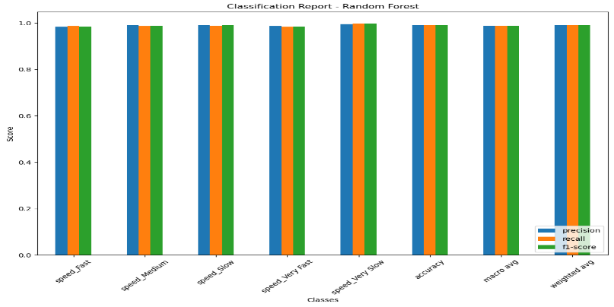
Fig,13 : Classification Report Metrics for Speed Prediction Using Random Forest

Random Forest performed very well with respect to speed class identification. High accuracy values were recorded in classes like "Very Slow" with 186,642 correct and "Very Fast" with 188,463 correct. The misclassifications are low, and classes that border with one another have some overlap. For example, "Speed_Slow" was correctly classified 124,352 times against misclassification as "Very Slow" 959 times and "Speed_Medium" was correctly classified 123,847 times with minor errors before such as only 2,009 instances misclassified as "Very Slow." Thus, in general, the model differentiates between the categories of speed with very few misclassifications.

The classification report for the Random Forest model indicates very good performance on all speed classes, where precision, recall, and F1-scores are very near to 1.0 in each class, for example, "Speed_Fast," "Speed_Medium," "Speed_Slow," "Speed_Very Fast," and "Speed_Very Slow." This would mean that the model always predicts accurately, correctly identifying the speed categories to which they belong, with high reliability. Also, the overall accuracy, macro average, and weighted average scores also tend very close to 1.0, thus establishing the model's robustness and effectiveness in classifying the speed categories. [section VII, Fig 12 & 13 as appendices]

Misclassified Samples Distribution in Principal Component Space (PC1 vs PC2) : The fig. 14. Misclassified samples in the space of the first two principal components: The total number of misclassified examples was 7,973 out of 756,000. Thus, the misclassification rate was about 1.05%. By looking at frame snippet of the data as shown in the following, one can notice that for some samples, values for the principal components are missing – NaN, which could also impair the model's performance in classifying them. The presence of these NaN values indicates that part of the data was not completely processed or that some principal components could not be calculated for all samples, which might be at least part of the reason for this misclassification. The following visualization shows how the misclassified points cluster and may provide some insights into patterns or areas where this model is performing poorly.

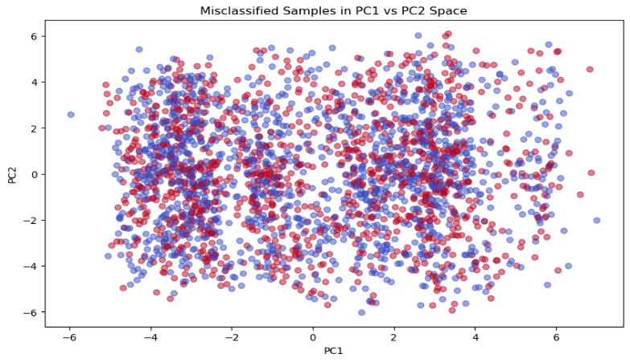Fig: 14 – Misclassified samples projected between PC1 & PC2

Feature Importances of Principal Components: Fig 15 showed feature importances for these principal components used in the model, and it highlighted which components contributed the most to the model's predictions. Among these, PC3 seemed to be the most important feature with significantly higher importance scores compared to others. Also, PC2 was substantially important while the rest such as PC8, PC5, and so on, were not that important. It suggested that PC3 and PC2 captured the most critical information needed in the model's decision-making process. [Section VII, Fig 15 as appendices.]

Runner-Up: The k-Nearest Neighbors classifier was high in accuracy to categorize at different speed categories. In general, it attained an accuracy of 0.98. Precision, recall, and f1-score metrics were very high for all the classes, ranging from 0.97 to 0.99. Confusion matrix returned very few misclassifications; most of the true labels were correctly predicted. In particular, the "speed Very Slow" class had a near-perfect recall of 1.00, showcasing the model's performance. All the macro and weighted averages of precision, recall, and f1-score were 0.98, indicating that the classifier did not lose much in effectiveness across different classes. Cross-validation scores from 0.971 to 0.972 further acknowledged the robustness of the model with a mean cross-validation score at 0.972, indicating that this k-NN model was efficient in distinguishing between different speed levels within the dataset. [Fig 16 and Fig 17]
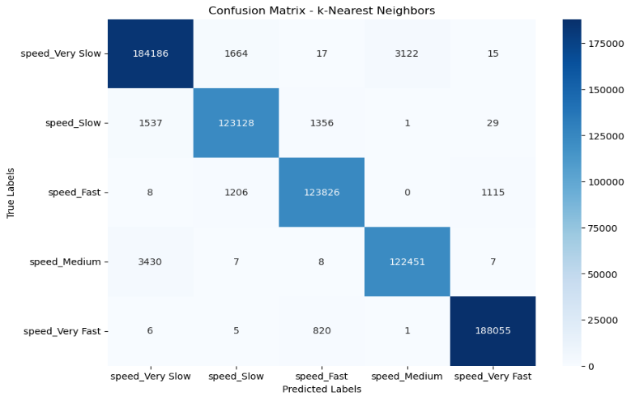FIG : 16 – confusion matrix for KNN

SVM performance: A Support Vector Machine classifier was used to predict the speed categories in a huge data set, subdivided into five classes: "speed Fast", "speed Medium", "speed Slow", "speed Very Fast", and "speed Very Slow". The data was processed in pieces so that available memory would not be wasted, after which an SVM with an RBF kernel was trained since it is more suitable for high-dimensional data. The chunking method allowed incremental learning and provided for the efficient training of the model without overloading the system, which ensured that the integrity of the learning process was not disrupted. This was further evaluated through cross-validation, where an accuracy of 98.12% was realized. The result of this classification is shown in the precision, recall, f1-scores, and the confusion matrix, whereby it indicates that the SVM has distinguished classes of speed categories very well with minimal misclassifications. This also established how effective and efficient the use of SVM could be with large datasets in the case of multi-class classification problems. It further validated the use of the chunking method in the face of large datasets for ensuring that the model performed accurately. [Section VII, Fig 18 & 19 as appendices]

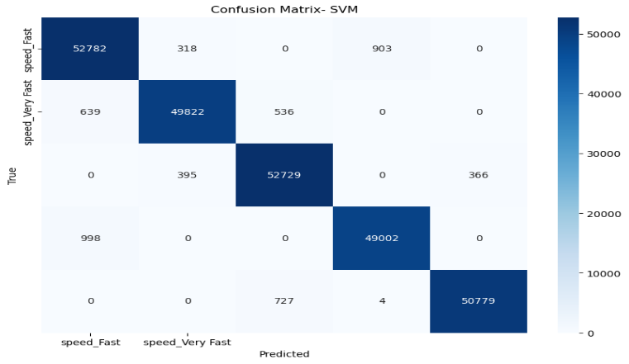 FIG :18 – confusion matrix for SVM

Chunking method: The dataset had more than 3 million samples, which were to be classified into five speed classes. It would have been impractical to process in one pass because of limitations in terms of both memory and computational power. Breaking this down into chunks of about 10,000 samples allowed for incremental learning using the chunking method, ensuring efficient model training. This was quite instrumental in avoiding overload within the system and making sure that the learning process remained intact. The chunking method also allowed for selective processing of the chunks with all class labels, ensuring construction of a balanced representative sample for the SVM classifier. This approach ensured that big data management becomes rather very robust for training and model performance without suffering from memory consumption, thus warrants application in this study.

Neural Network Performance: The performance of the Neural Network classifier was also quite good, with an accuracy measured at 0.97. As opposed to Random Forest and SVM, it constantly returned high values for precision, recall, and F1-scores, hence being a little less accurate. Its performance was strong due to its ability to model complex, nonlinear relationships in the data. This makes the Neural Network a viable option when advanced gait analysis tasks need to be performed. (section-VII Appendices, Fig 20, 21, 22 & 23)

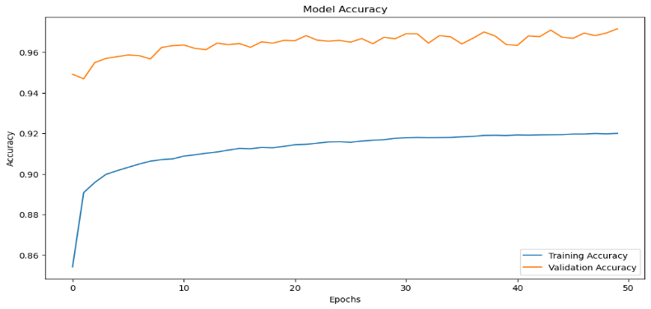Fig 20 : Model Accuracy Over Epochs for Training and Validation Datasets

Model Performance Over 50 Epochs Fig 20 includes training and validation data set accuracy and loss graphs. Accuracy in training began low, monotonically rose and levelled off near 92%. On the other hand, validation accuracy begins very high, ranging from 94% to 97%. More specifically, as can be seen from the accuracy graph, the model did learn lessons from the training data and generalized well to samples outside the training set with no overfitting evident.
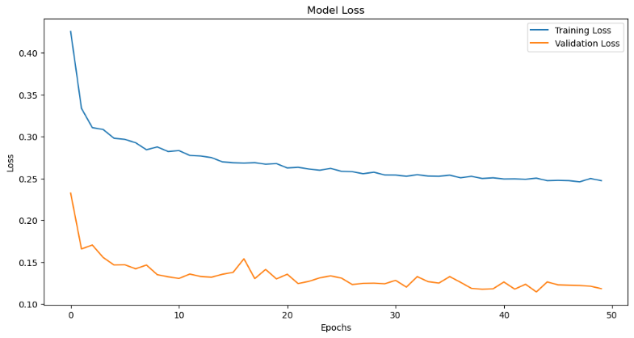
Fig 21: Model Loss Over Epochs for Training and Validation Datasets

The training loss, as observed in figure No. 21, was high and then depicted a gradually decreasing trend to 0.25, thus proving that there was a reduction in errors as the model trained. At the very last, the validation loss, at the beginning, had begun low. That followed a decreasing trend staying around 0.13 with minor fluctuations. This was an indication that the model was well-calibrated to generalize across the two different datasets because the training and validation losses were relatively constant. All these plots combined would show that the model is learning effectively, generalizing well, with stable and close metrics for both datasets, which indicate minimal overfitting.

Moderate performance: Different speed categories showed a very good performance for the Decision Tree classifier, reaching an accuracy of 0.93 overall. The metrics for precision, recall, and f1-score all turned out very high, within 0.92 to 0.97 across classes. The class "speed Very Slow" did an excellent job with recall and precision at 0.97, which makes this model excellent in recognizing this category with minimal errors. A confusion matrix showed some misclassifications mostly in classes "speed Slow" and "speed Medium," but even these were relatively minor. It can be seen that the macro and weighted averages for precision, recall, and f1-score were all 0.93, which proves that the classifier did indeed retain balanced and efficient performance across different speed levels. All cross-validation scores with a mean of 0.927 further confirm the strength and reliability of the Decision Tree model, making this model quite suitable for this task of classification. (section-VII Appendices, Fig 24 & 25) 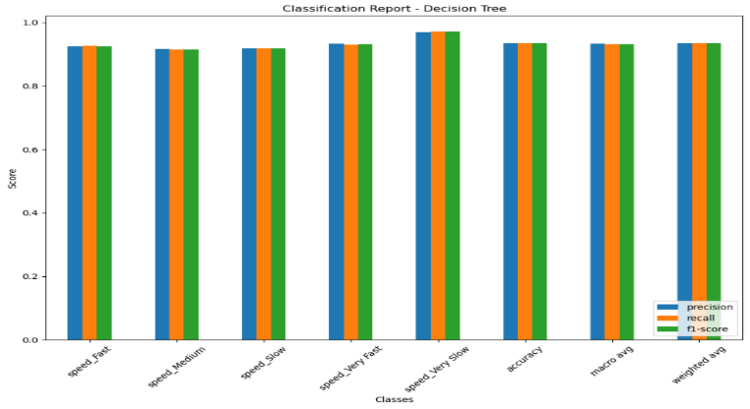FIG 25 -CLASSIFICATION REPORT FOR DECISION TREE

Underperforming Models:
Gradient Boosting Classifier: This model performed poorer, with an accuracy of 0.71, which generally did poorly on slower gait speeds. This is reflected in lower precision and recall values for these classes. (section-VII ,Fig 26 & 27)
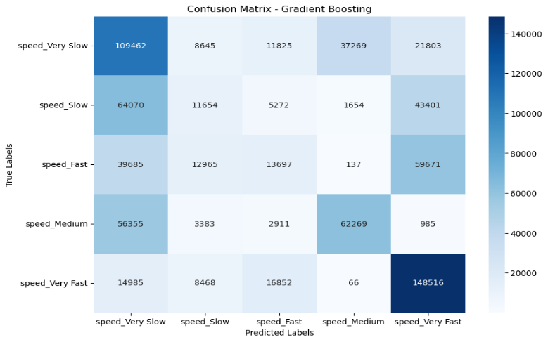
Fig 27:- Confusion Matrix for Gradient Boosting

The confusion matrix of Gradient Boosting model presented the performance of the model in the classification of different classes of speed categories.Every row represented a real class, and every column represented a predicted class.The elements on the diagonal gave the number of examples that were correctly classified, whereas elements off the diagonal gave the misclassifications. For example, while it correctly classified 109,462 samples as "speed_Very Slow," it miss-classified 21,803 of them as "speed_Very Fast." It is this matrix that underlined where the model did well and where badly—in particular, with confusion between classes like "speed_Very Slow" and "speed Very Fast" or "speed Slow.". Evaluation of the Gradient Boosting model gave huge misclassifications across classes "speed Slow" and "speed Fast" according to the confusion matrix. The classification report indicated that while it was quite good at classifying "speed_Very Slow" and "speed_Very Fast", it was quite poor at the rest of the speed categories and hence returned reduced precision, recall, and F1-scores for those classes.

Overall, the model was moderately accurate, performing better at both ends of the extreme spectrum of speed and showing notable challenges in differentiating between the middle categories.

Naive Bayes Classifier: The Naive Bayes classifier did a little worse than the other models, returning an overall accuracy of 0.45. The precision, recall, and f1-score changed a great deal across various categories of speed, thus capturing the poor performance of this model in this classification task.The recall rates for the "speed Fast" and "speed Very Slow" classes were 0.77 and 0.85, respectively, indicating that the model was relatively good at identifying these categories. However, other classes like "speed Medium" or "speed Very Fast" did not perform so well, where recall was as poor as 0.06 and 0.13. That means, in particular, although it was good at dealing with classes, it could generalize very poorly across all of them. In the confusion matrix there were very considerable misclassifications, more precisely in the "speed Fast" and "speed Slow". The macro average f1-score was 0.33, while the weighted average was 0.37, giving indications of the model about the global imbalance in performance. Cross-validation scores were quite coherent and averaged 0.453, further giving information on the lack of efficiency for the model to correctly classify the speed categories on the dataset.. [section-VII Appendices, Fig 28 & 29 ]
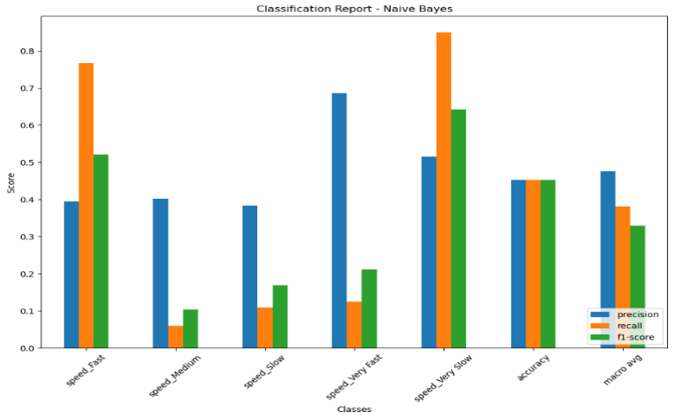Fig: 28 – Classification Report for Naïve Bayes

Logistic Regression: The performance of Logistic Regression models under different conditions has been evaluated, including standard Logistic Regression with and without detailed misclassification analysis and finally, models with L1 and L2 regularization. The standard Logistic Regression model without regularization turned out to be the least accurate, 40.49% accuracy with a misclassification rate of 59.50%. This substantially failed in the prediction of middle speed classes, as can be shown with the confusion matrix where every class is substantially misclassified into others.The classification report returns more details about the poor performance of the model for low precision and recall for the classes "Speed Fast" and "Speed Slow". Introducing L1 regularization slightly improved the accuracy to 46.77%. It significantly improved the recall for the class "Speed Very Slow" to an F1-score of 0.65 but "Speed_Medium" and alike continued to perform poorly, reflected in the confusion matrix. L2 regularization gave broadly similar improvements, with an accuracy of 45.71% and a corresponding confusion matrix showing the same sort of misclassification issues with middle-speed classes. Overall, while regularization did slightly improve the performance of the models, all versions of Logistic Regression really labored to correctly classify the classes of medium-speed vehicles, which was also constantly reflected in their confusion matrices and classification reports
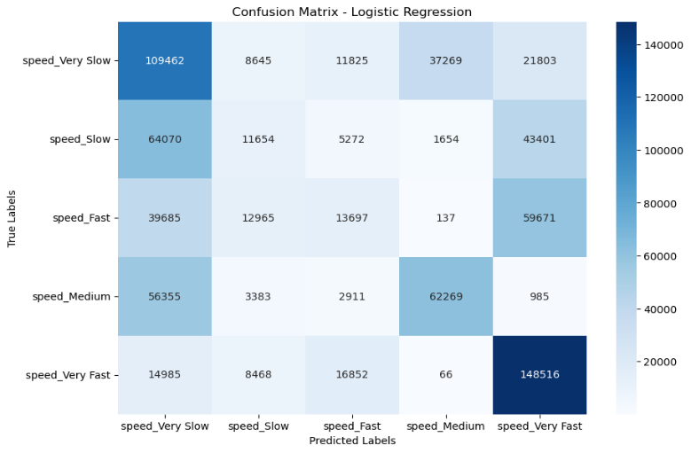
Fig 31: Confusion Matrix Analysis for Logistic Regression Model

L1 and L2 Regularization in Machine Learning: L1 and L2 regularization are techniques that prevent overfitting by adding penalties to the loss function.L1 regularization, or Lasso, shrinks some of the coefficients all the way down to zero; thus, it also conducts feature selection and gives a simplified model. L2 regularization, or Ridge, shrinks all coefficients toward zero because this is useful for handling multicollinearity and preserving all features with less importance. Elastic Net not only balances both but also conducts feature selection. (section-VII Appendices, Fig 30 & 31)

Summary: - Table No. 02 summarizes various classifier performances, where it can be noticed that a Random Forest model has the highest accuracy, precision, recall, and F1-score of 0.99, which means it performed best with very few misclassifications. KNN and SVM models also showed excellent performance with scores of 0.98 for all metrics, thus high accuracy and reliability. The Neural Network model followed with very strong performance in all metrics of 0.97. The Decision Tree was at 0.93 consistently for all metrics. Gradient Boosting followed with poor performance—slower speeds majorly reflected an accuracy of 0.71. Logistic Regression and Naive Bayes models performed very poorly with accuracies at 0.46 and 0.45, respectively. This had a lower precision, recall, and F1-scores that showed tremendous misclassifications. (section-VII Appendices, Table No. 02)

V. Discussion

Implications for gait analysis: This paper consolidates the expectation that by using machine learning classifiers the field of gait analysis will be enabled to further up its game, with the special interest being the estimation of speeds of walking using marker-based motion capture data. The good results of the ensemble methods like Random Forest and the good results of nonparametric models like k-Nearest Neighbors have shown that such models performed well with high-dimensional data and handled complex movement patterns. In a clinical context, where there is an earlier detection of abnormalities in gait, this could provide a very significant change in the outcome of treatment for people suffering from Parkinson's disease, cerebral palsy, and recovery after surgical intervention.

In a second place, the Support Vector Machines went through with an equally high performance, which ratifies more their utility for problems related to the gait analysis task. The chunking made the large data sets easily manageable because it broke the analysis performed sequentially into smaller units. This is key to achieving computational efficiency and also a key measure in avoiding memory overflows, which is quite a big problem that can come within SVM analysis and large data sets. Previous experiments also exhibited the potentiality of chunking methods for training an incrementally learned mass of SVM, without loss of classification quality. The chunking method not only helped in using the SVM in this study but also guaranteed that the model was able to process large, multiclass datasets with a very minimal loss of accuracy and further confirmed its application in real-time gait analysis systems.

The Neural Networks are somewhat less accurate than the Random Forest and the SVM, but on the other hand they are able to capture non-linear relationships embodied in the data, characteristic of very weak dependencies. This makes them very suitable for more nuanced tasks of gait analysis, for example, telling apart very similar gait patterns, which might mean different underlying health conditions.

Limitations and Future Work: From the given results, this paper sounds promising. However, this study has a lot of limitations, especially with data imbalance. The dataset used in this study may not be inclusive enough to represent the diversity of gait patterns that can be found in bigger populations, and therefore generalizing these findings at best might be limited. Addressing data imbalance through synthetic data generation, oversampling, and advanced deep learning methods may further improve the models' potential for correctly classifying the less common gait patterns, subsequently boosting the practical value of such models across a broad range of clinical scenarios.

Further, while the study in this paper has been limited to the classification of gait speeds, further refinement of these models would allow for the additional classification of other key gait characteristics, such as stride length, cadence, and symmetry, which are other very important indicators of gait health. In this manner, classification could be expanded to allow for a more in-depth evaluation of gait and, hence, allow for the earlier detection of movement disorders.

Another area of future research is to find the optimal possible integration of such machine-learning models with wearables, such as IMUs or pressure-sensitive insoles. Such devices can be used to capture data in real time, hence monitoring continuously for immediate feedback. Real-time adjustments using such devices can be of great advantage, especially in a rehabilitation scenario, with the potential to further optimize the patient's outcomes.

This work also paves the way for interpretability of machine learning models within clinical settings. For instance, although random forests and support vector machines have been shown to have high accuracy, their black-box nature has posed many challenges with respect to their clinical adoption. Future work may focus on developing explainable AI techniques that give clinicians organizational insight on deconstructing the black-box models so as to gain trust and speed up their adoption into clinical environments.

Scalability and real-time applications: Even in this study, scalability of models used in machine learning forms a very important consideration, mostly in integrating these systems into real-time clinical applications. The more important aspect concerning the scalability of the models applied will be the capability to handle heavy datasets efficiently without any loss in accuracy, something quite important for the development of practical gait analysis systems in real time. The SVM model adopted here is a good example of how computational challenges can indeed be controlled to ensure the model remains responsive and accurate during application to extensive datasets. This scalability allows for potential future applications in clinical settings where real-time analysis can give immediate feedback to alter patient outcomes.

VI. CONCLUSION

To sum up, the current work showcases the promising potential of machine learning-based classifiers for gait analysis. Random Forest, k-Nearest Neighbours, and SVM particularly stand out as the most effective models in tasks associated with the classification of forward walking speeds, while Neural Networks present promising techniques for tasks involving the modelling of complex non-linear relationships. It was therefore also justified, based on previous studies, that the chunking method to train the SVM would play a critical role in handling huge datasets, carrying out fast computation without bigger drops in accuracies.

These results make an important contribution to gait analysis, as the developed models become available to be utilized in clinical systems seeking improvements in diagnosing and treating disorders related to gait. The paper also paves the way for further research within the imbalanced data scenario, model interpretability, and real-time implementations into the clinical gait analysis domain.

Broader Impact and Future Potential: The impact of this research is broad, for it is within the gait analysis domain that the possibility of generalization into several other areas—in particular, a wide range of areas dealing with the analysis of human motion—is opened up. In this respect, the developed methodologies and models are applicable to other kinds of movement patterns, which will facilitate a better understanding of a variety of health conditions and, in turn, improvement in the efficiency of a rehabilitation program. Future work could also explore the integration of such models with emergent technologies such as augmented reality and virtual reality to engender immersive, interactive rehabilitation environments with a concomitant advance in patients' involvement and outcomes.

Final thoughts: As machine learning progresses, its use in routine patient care is bound to expand. This paper emphasizes the needs that further improvement of these models have to overcome the existing limitations in order to render them both accurate and interpretable for real-world healthcare. Here, the achieved promising results accentuate that application of machine learning can foster gait analysis, thus forming the basis for developing of next-generation systems that can help in the improvement of patient care through much more precise and efficient evaluation of gait patterns.

Acknowledgements:

I would like to express my sincere gratitude to my supervisor, Mr. Tayyab Ahmad Ansari, for his continuous support, guidance, and encouragement throughout this project, I also thank my family and friends for their unwavering support and patience.

References:
- Muro-de-la-Herran, A., Garcia-Zapirain, B., & Mendez-Zorrilla, A. (2014). Gait Analysis Methods: An Overview of Wearable and Non-Wearable Systems, Highlighting Clinical Applications. Sensors, 14(2), 3362-3394. doi:10.3390/s140203362.
- Santos, G., Wanderley, M., Tavares, T., & Rocha, A. (2022). A multi-sensor human gait dataset captured through an optical system and inertial measurement units. Scientific Data, 9(1). https://doi.org/10.1038/s41597-022-01638-2.
- Chau, T. (2001). A Review of Analytical Techniques for Gait Data. Part 1: Fuzzy, Statistical and Fractal Methods. Gait Posture, 13(1), 49-66.
- Baker, R. (2006). Gait Analysis Methods in Rehabilitation. Journal of NeuroEngineering and Rehabilitation, 3, 4. doi:10.1186/1743-0003-3-4.
- Munoz-Ospina, B., Alvarez-Garcia, D., Clavijo-Moran, H. J. C., Valderrama-Chaparro, J. A., García-Peña, M., Herrán, C. A., Urcuqui, C. C., Navarro-Cadavid, A., & Orozco, J. (2022). Machine learning classifiers to evaluate data from gait analysis with depth cameras in patients with Parkinson’s disease. Frontiers in Human Neuroscience, 16. https://doi.org/10.3389/fnhum.2022.826376.
- Whittle, M. W. (2014). Gait Analysis: An Introduction. Butterworth-Heinemann.
- Breiman, L. (2001). Random Forests. Machine Learning, 45(1), 5-32.
- Zeni, J. A., Richards, J. G., & Higginson, J. S. (2008). Two Simple Methods for Determining Gait Events during Treadmill and Overground Walking Using Kinematic Data. Gait & Posture, 27(4), 710-714. doi:10.1016/j.gaitpost.2007.07.007.
- Mannini, A., & Sabatini, A. M. (2010). Machine Learning Methods for Classifying Human Physical Activity from On-Body Accelerometers. Sensors, 10(2), 1154-1175. doi:10.3390/s100201154.
- Altilio, R., Rossetti, A., Fang, Q., et al. (2021). A comparison of machine learning classifiers for smartphone-based gait analysis. Med Biol Eng Comput, 59, 535-546. doi:10.1007/s11517-020-02295-6.
- Rohan, A., Mohamed, R., Tarek, H., & Seunghae, K. (2020). Human Pose Estimation-Based Real-Time Gait Analysis Using Convolutional Neural Network. IEEE Access, 8
- Slemenšek, J., Fister, I., Geršak, J., Bratina, B., van Midden, V. M., Pirtošek, Z., & Šafarič, R. (2023). Human Gait Activity Recognition Machine Learning Methods. Sensors, 23(2), 745. https://doi.org/10.3390/s23020745.
- Yang, M., Zheng, H., Wang, H., & McClean, S. (2009). Feature selection and construction for the discrimination of neurodegenerative diseases based on gait analysis. Third IEEE Int Conf Pervasive Comput Technol Healthc.
- Witten, I. H., Frank, E., & Hall, M. A. (2011). Data Mining: Practical Machine Learning Tools and Techniques (3rd ed.). Morgan Kaufmann.
- Privietha, P., & Raj, V. J. (n.d.). Deep learning technic on gait analysis. Retrieved from https://iqac.kamarajcollege.ac.in/wp-content/uploads/3.3.2-Deep-Learning-Technic-on-Gait-Analysis.pdf
- Alfayeed, S. M., & Saini, B. S. (2021). Human Gait Analysis Using Machine Learning: A Review. 2021 International Conference on Computational Intelligence and Knowledge Economy (ICCIKE), Dubai, United Arab Emirates, pp. 550-554. doi:10.1109/ICCIKE51210.2021.9410678.
- Hebenstreit, F., Leibold, A., Krinner, S., Welsch, G., Lochmann, M., & Eskofier, B. M. (2014). Description of the GaitPhase Database.
- Jolliffe, I. T. (2002). Principal Component Analysis (2nd ed.). Springer.
- Pundir, A., et al. (2024). Enhancing gait recognition by multimodal fusion of mobilenetv1 and xception features via PCA for OaA-SVM classification. Scientific Reports, 14(1), 1-17.
- Bishop, C. M. (2006). Pattern Recognition and Machine Learning. Springer.
- Goodfellow, I., Bengio, Y., & Courville, A. (2016). Deep Learning. MIT Press.
- Fawcett, T. (2006). An introduction to ROC analysis. Pattern Recognition Letters, 27(8), 861-874.
- Hribernik M, Umek A, Tomažič S, Kos A. Review of Real-Time Biomechanical Feedback Systems in Sport and Rehabilitation. Sensors (Basel). 2022.
- Park, H., et al. (2023). Classification of gait phases based on a machine learning approach using muscle synergy. Frontiers in Human Neuroscience, 17. doi:10.3389/fnhum.2023.1201935.
- Kohavi, R. (1995). A study of cross-validation and bootstrap for accuracy estimation and model selection. International Joint Conference on Artificial Intelligence (IJCAI), 14, 1137-1145.
- S. Shetty and Y. S. Rao, "SVM based machine learning approach to identify Parkinson's disease using gait analysis," 2016 International Conference on Inventive Computation Technologies (ICICT), Coimbatore, India, 2016, pp. 1-5, doi: 10.1109
- B. Najafabadian, H. Jalali, A. Sheibani and K. Maghooli, "Neurodegenerative Disease Classification Using Nonlinear Gait Signal Analysis, Genetic Algorithm and Ensemble Classifier," Electrical Engineering (ICEE), Iranian Conference on, Mashhad, Iran, 2018.
- Mangasarian, O. L., & Thompson, M. E. (2008). Chunking for massive nonlinear kernel classification. Optimization Methods and Software, 23(3), 365–374. https://doi.org/10.1080/10556780701611976.
- Kingma, D. P., & Ba, J. (2014). Adam: A Method for Stochastic Optimization 1412.6980 (arxiv.org))
- Friedman, Jerome H. “Greedy Function Approximation: A Gradient Boosting Machine.” The Annals of Statistics, vol. 29, no. 5, 2001, pp. 1189–232. JSTOR, http://www.jstor.org/stable/2699986. Accessed 22 Aug. 2024.

VI. APPENDICES

Table 2 : Summary of Classifier Performance Results
Classifier | Accuracy | Precision | Recall | F1-Score | Notes
Decision Tree | 0.93 | 0.93 | 0.93 | 0.93 | Consistent performance across all classes
KNN | 0.98 | 0.98 | 0.98 | 0.98 | High accuracy and minimal misclassifications.
Gradient Boosting | 0.71 | 0.70 | 0.68 | 0.68 | Lower performance, struggles particularly with slower speeds.
Random Forest | 0.99 | 0.99 | 0.99 | 0.99 | Best performance with minimal misclassifications.
Neural Network | 0.97 | 0.97 | 0.97 | 0.97 | Strong performance, slightly below Random Forest.
Navies bias | 0.45 | 0.48 | 0.38 | 0.33 | Performance is below average, especially in recall and F1-score.
SVM | 0.98 | 0.98 | 0.98 | 0.98 | Excellent performance, comparable to KNN, with high accuracy.
Logistic Regression (L1 Regularization) | 0.47 | 0.47 | 0.47 | 0.40 | Slight improvement with L1 regularization, but still underperforming.
Logistic Regression (L2 Regularization) | 0.46 | 0.41 | 0.41 | 0.39 | Similar results to basic Logistic Regression, still underperforming
Logistic Regression | 0.46 | 0.41 | 0.41 | 0.39 | Poor performance, significant misclassifications

-
Fig, 1 : methodology

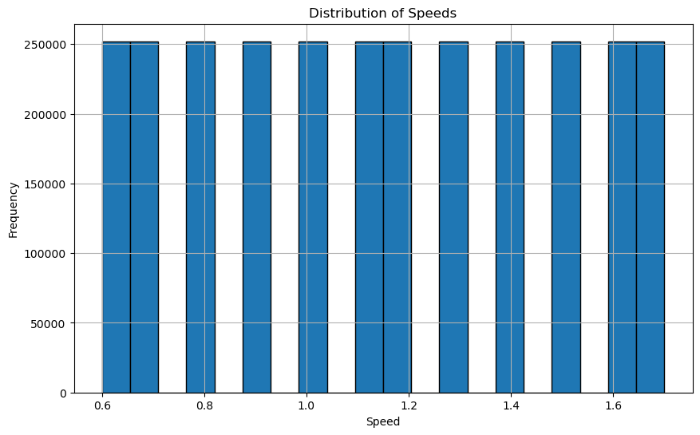
Fig. 2 : Distribution of Speeds:
This plot shows a histogram or bar chart depicting the frequency of different speeds in your dataset. The x-axis would represent speed values, and the y-axis would show the frequency (how often each speed occurs). A uniform distribution might indicate balanced data collection across different speeds.

Fig. 3 : Sensor Readings Over Time:
This plot visualize sensor readings over time for two different sensors, such as L_FCC_x and R_FCC_x. The x-axis would represent time (or sample points), and the y-axis would show sensor readings. This plot could be used to observe the periodic nature of the sensor data, which is common in gait analysis.

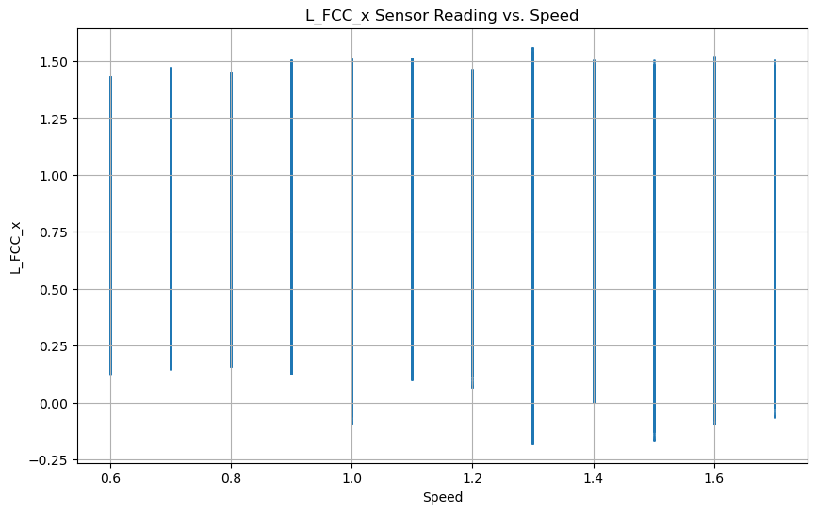
Fig. 4 : Sensor Reading vs. Speed:
This plot show the relationship between sensor readings and different speed values. The x-axis represents speed, and the y-axis represents the sensor reading. This could be a scatter plot or a line plot, useful for identifying any correlation between speed and sensor measurements.
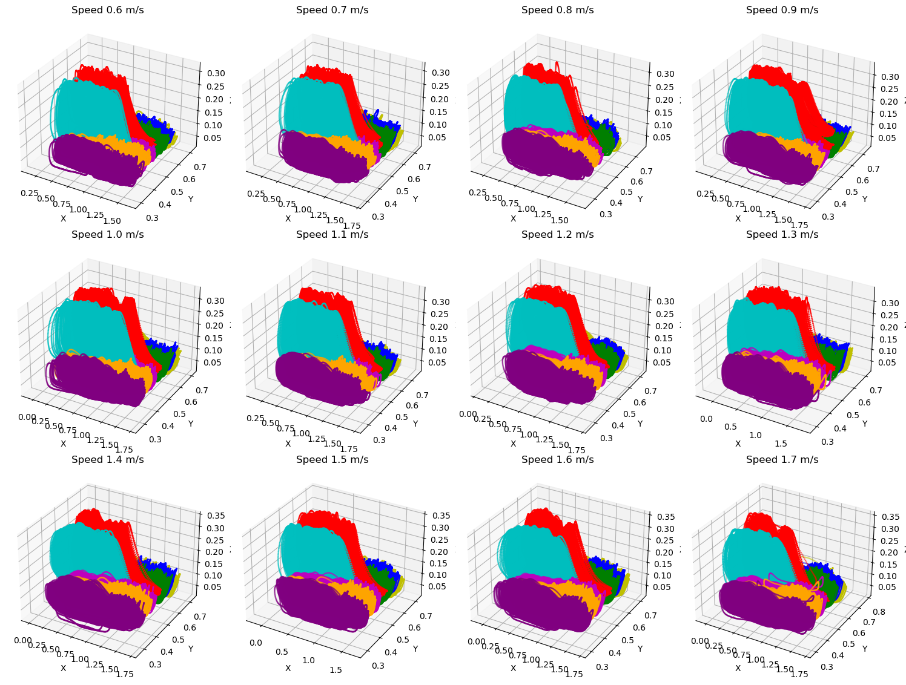
Fig.5: 3D Gait Analysis Across Different Walking Speeds:
3D plots comparing gait data at various speeds (0.6 to 1.7 m/s). Each plot likely represents spatial foot position or pressure distribution, with color coding differentiating data types. This visualization helps analyze how gait patterns change with speed.

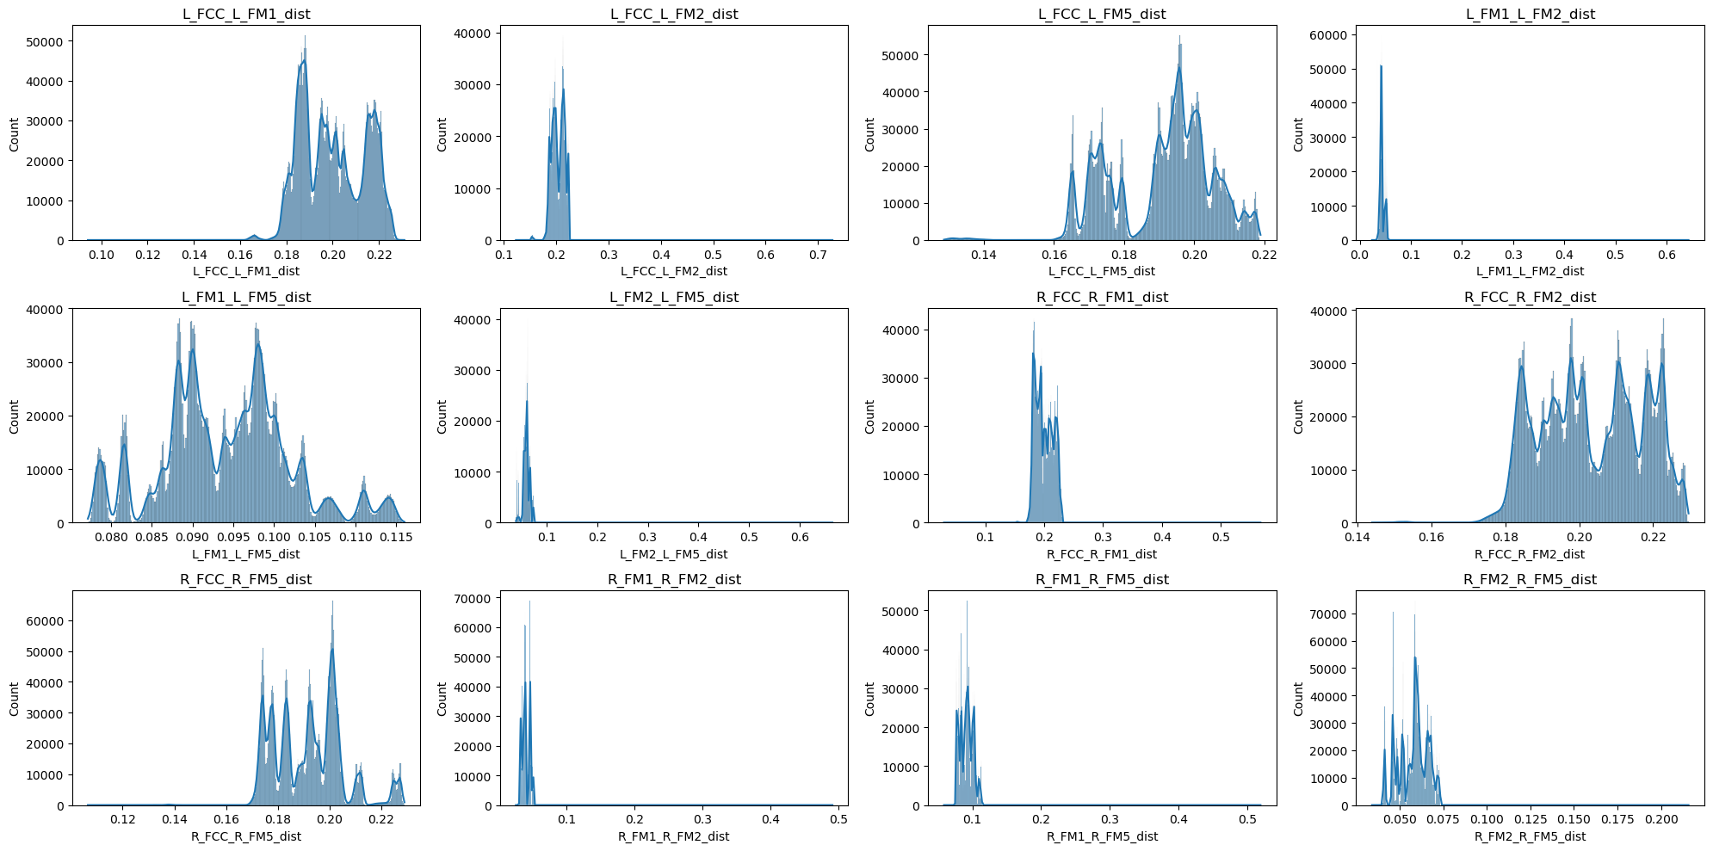
Fig. 6 : Distribution of Distances Between Gait Markers :The image shows multiple histograms, each representing the distribution of distances between different pairs of gait markers or features (e.g., L_FCC_L_FM1_dist, R_FCC_R_FM1_dist). The x-axis in each plot represents the distance, while the y-axis represents the count or frequency of those distances.

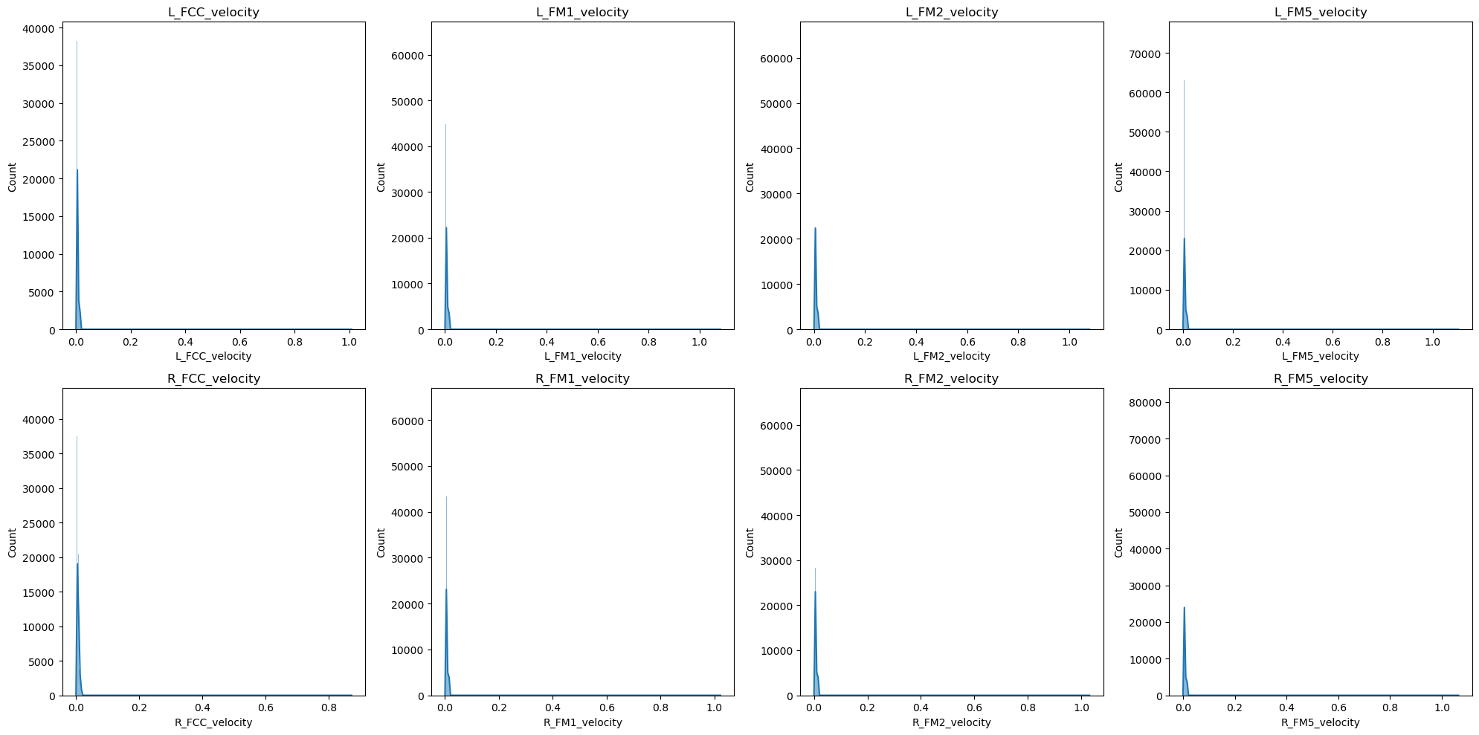
Fig 7 : Velocity Distribution of Gait Markers : The image shows a set of histograms displaying the distribution of velocities for different gait markers, such as L_FCC_velocity, R_FM1_velocity, etc. The x-axis represents the velocity, and the y-axis shows the count or frequency of these velocity values

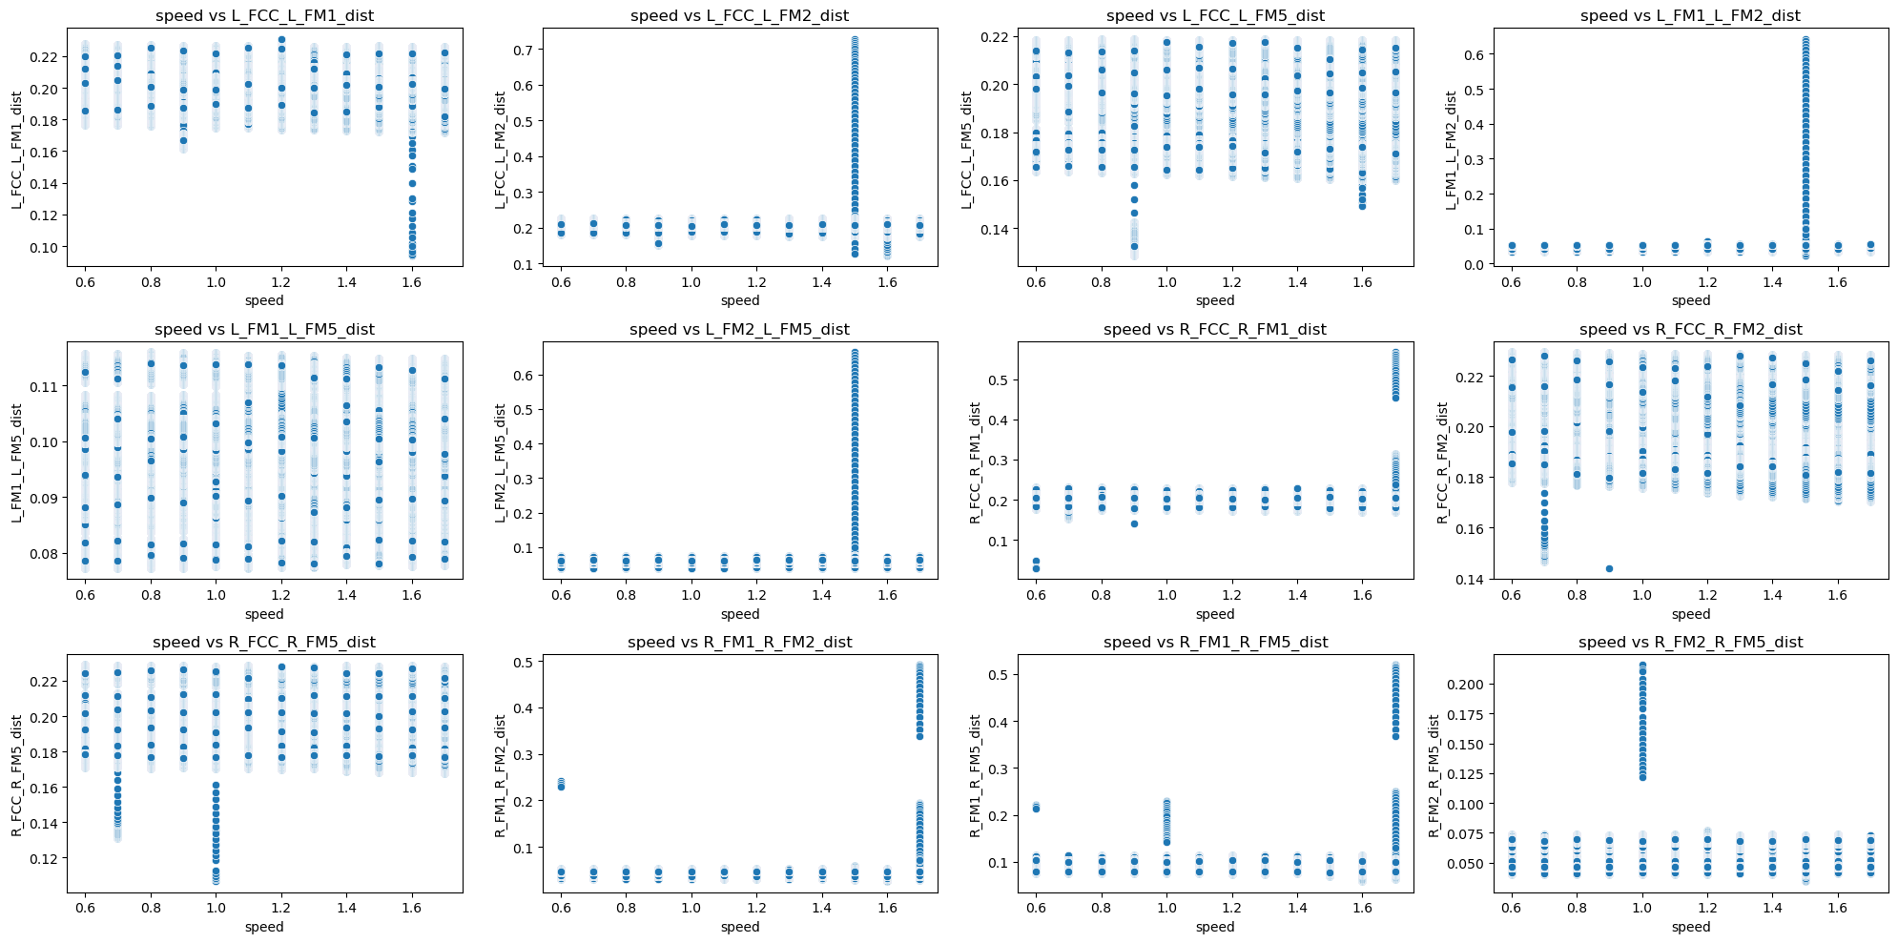

Fig. 8: Relationship Between Gait Marker Distances and Speed : The image displays a series of scatter plots showing the relationship between speed and the distances between various gait markers (e.g., L_FCC_L_FM1_dist). The x-axis represents speed, and the y-axis represents the distance.

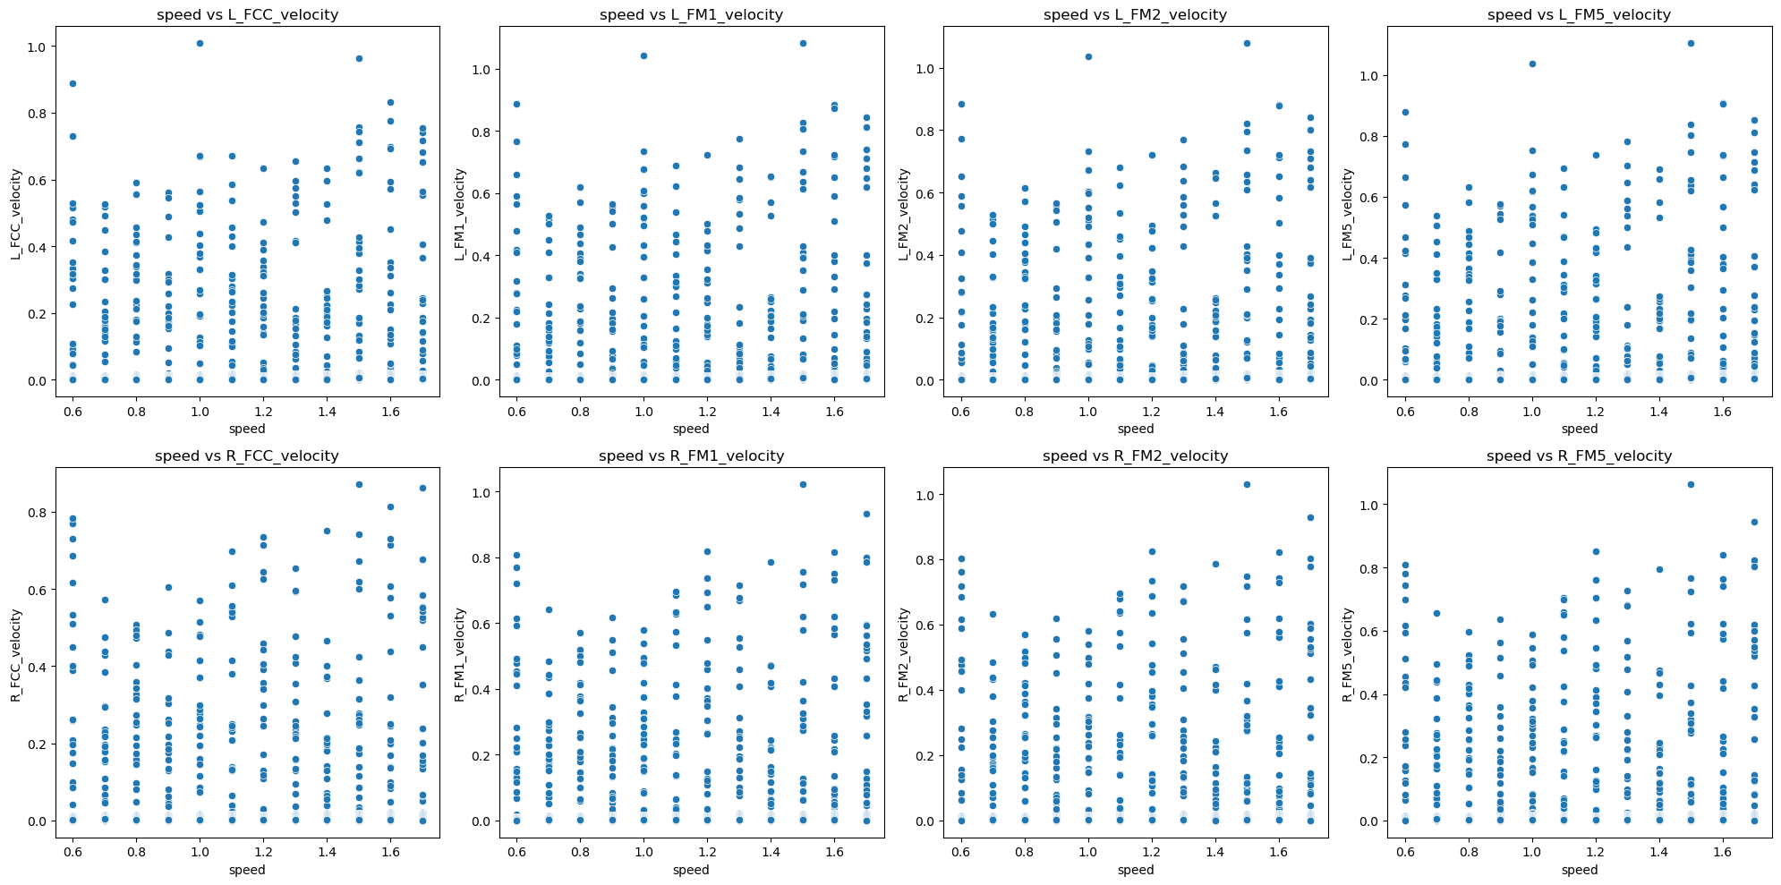
Fig. 9: Relationship Between Gait Marker Velocities and Speed: The image displays scatter plots illustrating the relationship between speed and the velocities of various gait markers (e.g., L_FCC_velocity, R_FM1_velocity). The x-axis represents speed, and the y-axis represents velocity.

p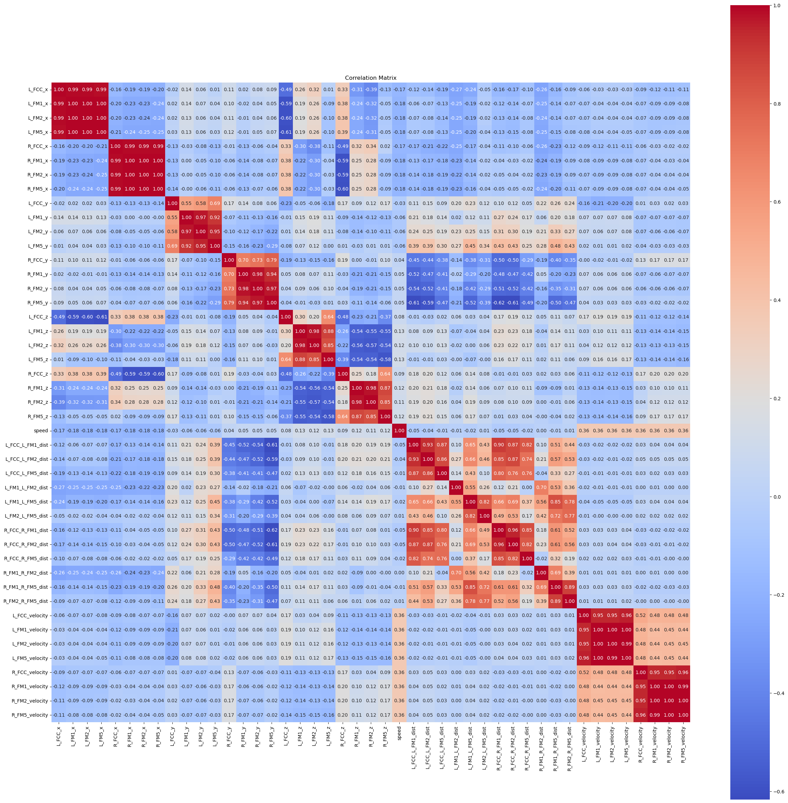

Fig. 10: Correlation Matrix of Gait Markers, Velocities, and Distances:
The image shows a correlation matrix, which visually represents the correlation coefficients between different gait markers and their corresponding velocities and distances. The matrix uses a color gradient, where red indicates a strong positive correlation,
blue indicates a strong negative correlation, and lighter colors indicate weaker correlations.


Fig. 11 : explained variance ratio by principal component


Fig, 12: Confusion Matrix for Speed Prediction Using Random Forest


Fig,13 : Classification Report Metrics for Speed Prediction Using Random Forest


Fig : 14 – misclassified samples distributed between PC1 & PC2

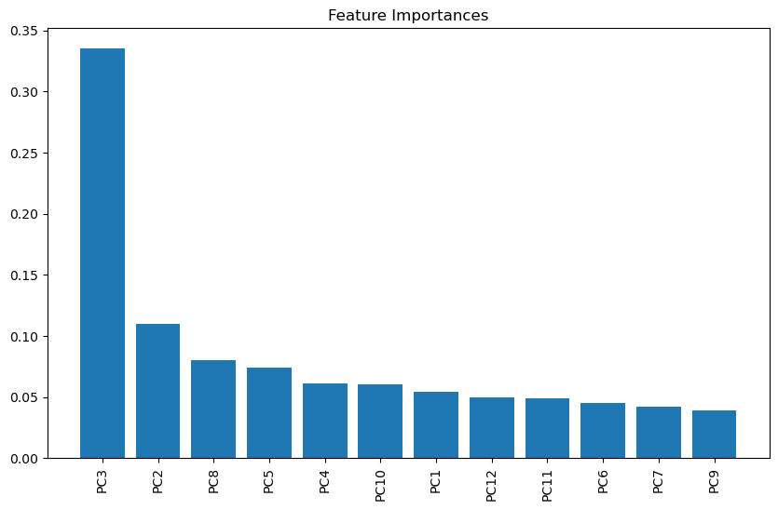
Fig 15 : Feature Importances of Principal Components


FIG : 16 – confusion matrix for KNN

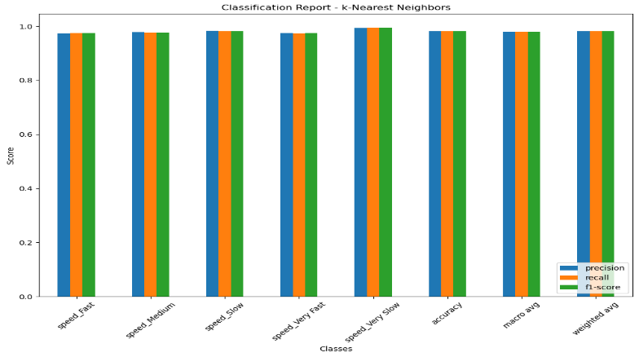
FIG:17 – CLASSIFICATION REPORT FOR KNN


FIG :18 – confusion matrix for svm

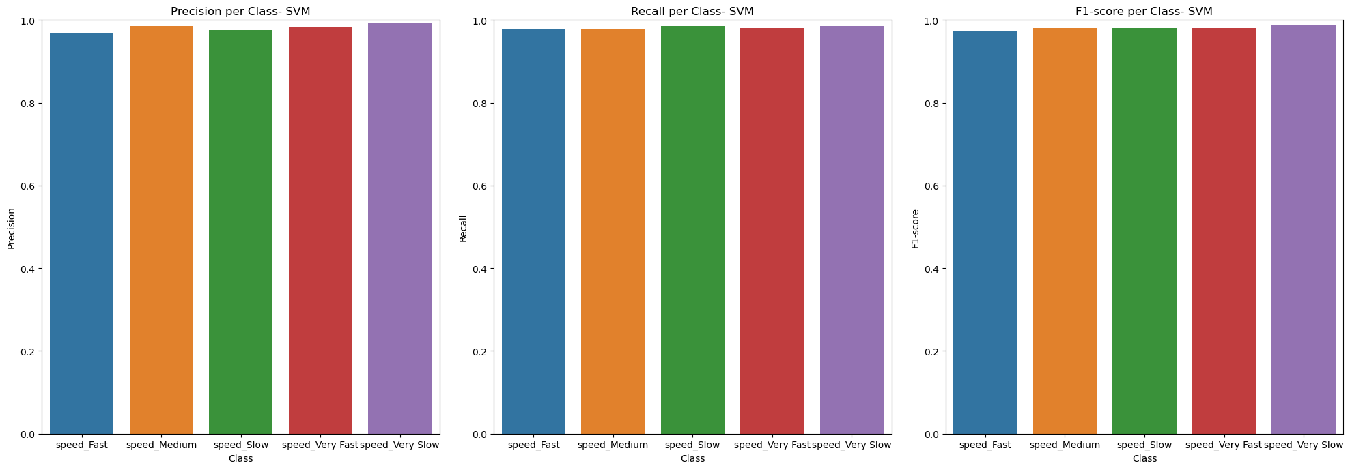
FIG 19 – CLASSIFICATION REPORT FOR SVM

 Fig 20 : Model Accuracy Over Epochs for Training and Validation Datasets

 Fig 21:-Model Loss Over Epochs for Training and Validation Datasets"

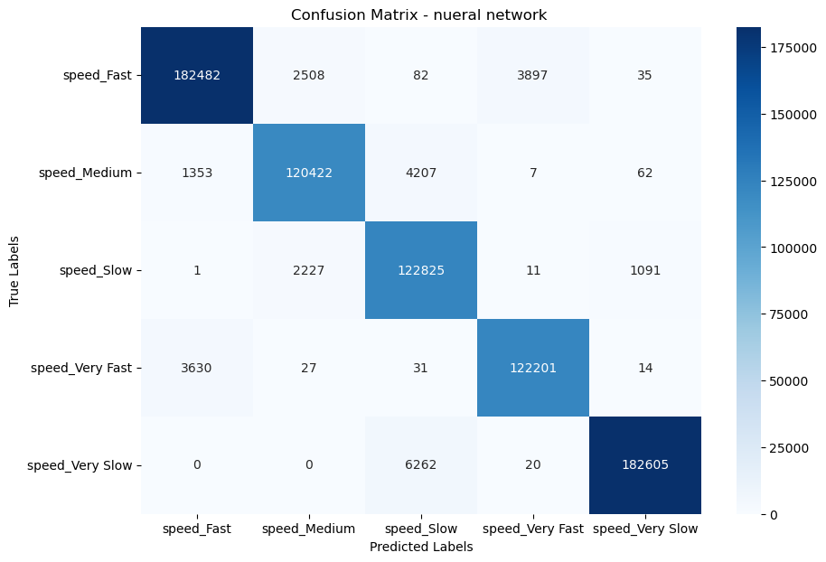
FIG: 22 - CONSFUSION MARTIX FOR NUERAL NETWORK

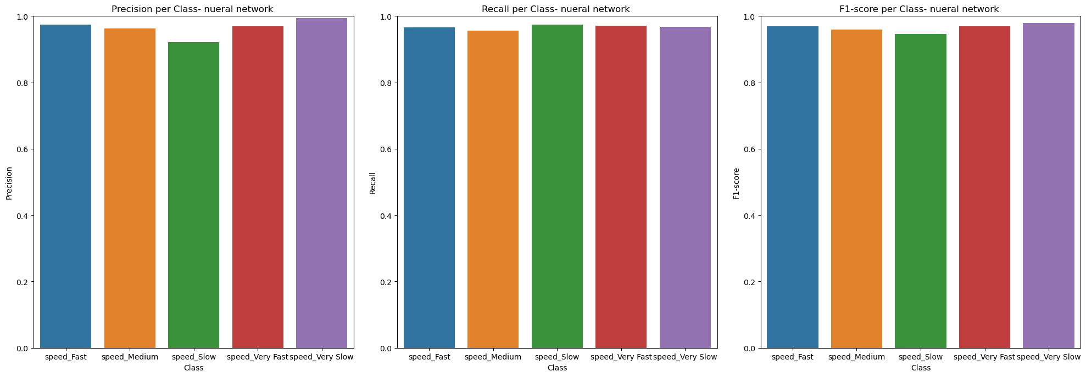
FIG : 23 – CLASSIFICATION REPORT FOR NUERAL NETWORK

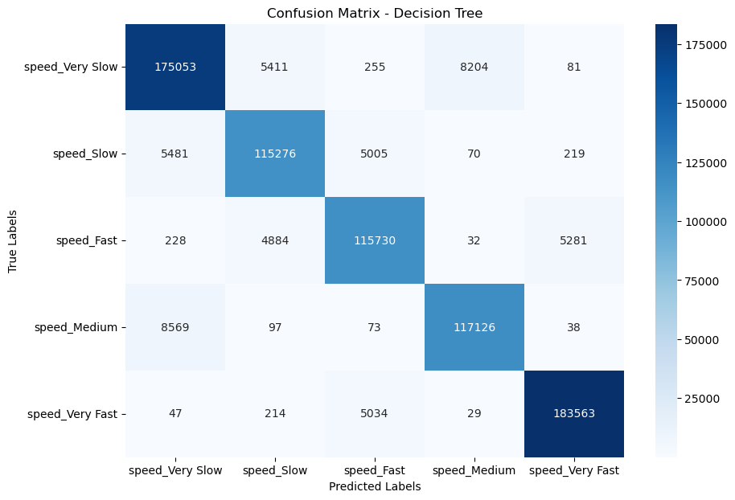
FIG : 24- CONFUSTION MATRIX FOR DECISION TREE


FIG 25 -CLASSIFICATION REPORT FOR DECISION TREE

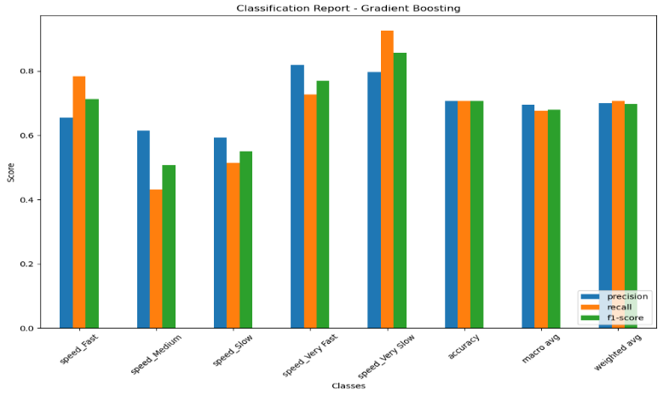
Fig 26 :- Classification Report for Gradient Boosting Model

 Fig 27 :-Confusion Matrix for Gradient Boosting

Fig : 28 – Classification Report for Naïve Bayes

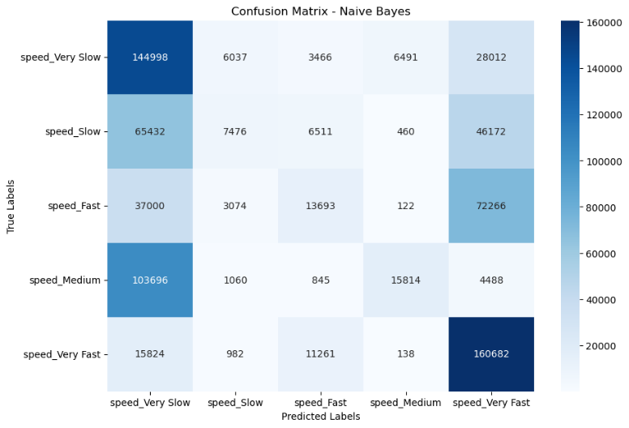
FIG : 29 – CONFUSTION MARTIX FOR NAÏVE BAYES

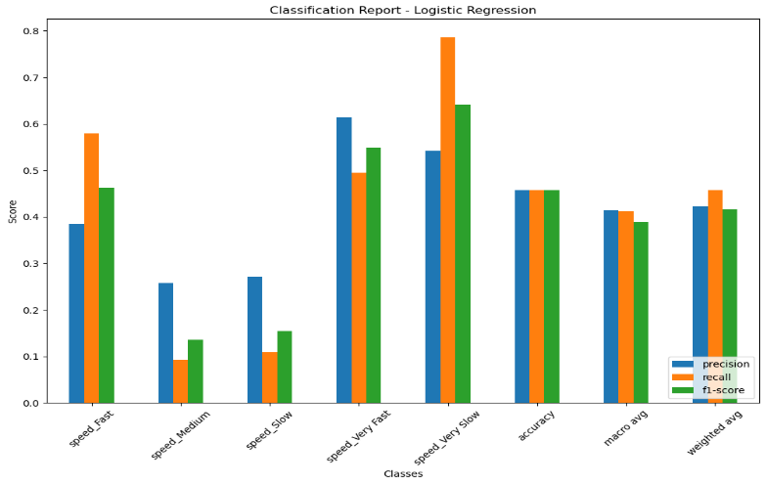
Fig 30 :- Performance Summary of Logistic Regression Model Across Speed Classes


Fig 31 : Confusion Matrix Analysis for Logistic Regression Model

